**Longish Term Paper**

**ON**

**“An analytical study on impact of EQ on productivity of IT employees at workplace in Pune”**

**Subject-** Research Methodology

**Subject Code**- PG 202

**Trimester** II

3rd Internal Evaluation

For The Award of

**POST GRADUATE DIPLOMA IN MANAGEMENT**

**(Batch 2024-26)**

**AWARDED BY**

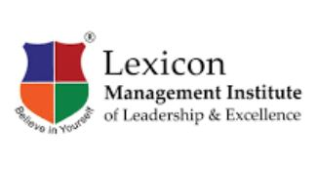

**SUBMITTED TO**

Dr. Kashmira Lonkar

**SUBMITTED BY**

|  |  |
| --- | --- |
| PRN | Name of students |
| 269 | Utsa Paul |
| 111 | Khushi Malviya |
| 304 | Nandita Bhoyar |
| 038 | Ankita Baral |
| 266 | Tiya Paul |
| 262 | Tanvi Nalband |
|  |  |

**LEXICON MANAGEMENT INSTITUTE OF LEADERSHIP & EXCELLENCE, WAGHOLI, PUNE**

**DECLARATION**

We the undersigned, studying in the first year of POST GRADUATE DIPLOMA IN MANAGEMENT (PGDM) at Lexicon Management Institute of Leadership and Excellence, MILE Tower, Wagholi, Pune, hereby declare that we have completed the Longish Term Paper “**An analytical study on impact of EQ on productivity of IT employees at workplace in Pune**”as a part of the course requirements- 3rd Internal evaluation for the **subject Research Methodology (Tri- II**) for award of POST GRADUATE DIPLOMA IN MANAGEMENT (PGDM) Program.

We also declare that the work undertaken by me is original and has not been copied from any other source. We further declare that the information presented in this project is true and original and has not been submitted to Lexicon or any other Institute for any other examination, before this. It is based on the original research work and will be used only for the academic purpose by following all the research ethics guidelines. The research will not be produced in any condition as a source of information to an industry for any other purpose watsoever.

Date: 07/03/2025

Place: Pune

|  |  |  |
| --- | --- | --- |
| PRN | Name of students | Sign |
| 269 | Utsa Paul |  |
| 111 | Khushi Malviya |  |
| 304 | Nandita Bhoyar |  |
| 038 | Ankita Baral |  |
| 266 | Tiya Paul |  |
| 262 | Tanvi Nalband |  |

**ACKNOWLEDGEMENT**

It is our privilege to express gratitude & sincere thanks to **Lexicon Management Institute of Leadership and Excellence, Pune** for giving the opportunity to undertake the LTP report on the topic **“Title”.**

We express sincere thanks to my research supervisor, Dr. Kashmira Lonkar, for guiding from the inception till the successful completion of the LTP.

We sincerely acknowledge her for extending her valuable guidance, support for literature, critical reviews of projects &researches, above all the moral support she provided us at all stages of this LTP. We would also like to thank the supporting stakeholders in their contribution and cooperation throughout this LTP.

|  |  |  |
| --- | --- | --- |
| PRN | Name of students | Sign |
| 269 | Utsa Paul |  |
| 111 | Khushi Malviya |  |
| 304 | Nandita Bhoyar |  |
| 038 | Ankita Baral |  |
| 266 | Tiya Paul |  |
| 262 | Tanvi Nalband |  |

**EXECUTIVE SUMMARY**

This study highlights the importance of Emotional Intelligence (EI) in workplace productivity, focusing on Pune’s IT sector. EI enhances stress management, teamwork, leadership, and overall employee performance. Higher EI improves engagement, communication, and conflict resolution while reducing burnout. Emotionally intelligent leaders foster motivation and trust, making EI training crucial for organizational success. Companies should implement EI programs, stress management initiatives, and team-building exercises to promote a positive work culture. Future research should explore EI’s role in remote work, different industries, and AI-driven EI tools. Investing in EI boosts productivity, well-being, and long-term growth.

**Table of Contents**

Contents

Chapter I - Introduction 7

1.1 Aims and Objectives of the Study 9

1.2 Significance of the Study 9

1.3 Limitations of the Study 10

1.4 Scope for Further Research 11

Chapter 2 – Sector Profile: IT Sector 12

2.1 Introduction 12

2.2 Brief History 12

2.3 Theoretical Foundation 13

2.4 Issues and Challenges 13

2.5 SWOT Analysis 15

Chapter 3 – Literature Review 17

Chapter 4 – Research Methodology: 26

4.1 Introduction 26

4.2 Research Methods 26

4.3 Hypothesis 26

4.4 Research Question 27

4.5 Methods of data collection 27

4.6 Sample size, sampling type 27

4.7 Method of analysis 27

Chapter 5 – Data Analysis: 28

5.1 Introduction 28

5.2 Reasoning Utilized 28

5.3 Data Analysis tools used 28

Hypothesis Testing & Statistical Part 38

5.4 Conclusion 39

Chapter 6 – Findings & Suggestions: 41

6.1 Findings 41

6.2 Suggestions 44

6.3 Conclusion 45

Chapter 7 – Conclusion 46

7.1 Introduction 46

7.2 Implications for Organizations 48

8 References/Bibliography 50

9. ANNEXURE 51

9.1 Questionnaire: 51

9.2 Responses: 52

## Chapter I - Introduction

The modern workplace is evolving, with Emotional Quotient (EQ) gaining recognition alongside technical skills. EQ refers to the ability to understand, regulate, and influence emotions, playing a crucial role in communication, teamwork, and stress management. Unlike technical expertise, EQ enhances workplace relationships, fosters collaboration, and improves overall productivity.

This chapter explores EQ’s significance in workplace interactions, focusing on IT professionals in Pune, a leading technology hub in India. Given the industry’s high-pressure environment, strong EQ helps professionals navigate challenges, resolve conflicts, and maintain a positive work culture.

EQ consists of five key components: self-awareness, self-regulation, motivation, empathy, and social skills. Leaders and employees with high EQ contribute to better teamwork, morale, and efficiency, while its absence can lead to workplace stress and miscommunication. As IT continues to grow, EQ remains a critical factor in career success and organizational development.

The IT Industry in Pune

Pune, often referred to as the "Oxford of the East," has grown into a major IT hub, attracting multinational corporations and startups. Leading companies like Infosys, TCS, Accenture, and Capgemini have established a significant presence, employing thousands of professionals involved in advanced technologies and global projects.

However, this rapid growth has brought unique challenges. The IT sector in Pune is marked by tight deadlines, evolving client expectations, and the constant need for upskilling. Employees often work long hours, face intense competition, and feel pressure to deliver high-quality results. In such a demanding environment, EQ becomes an essential skill for managing stress, balancing work-life priorities, and navigating workplace dynamics effectively.

The Role of EQ in IT Workplaces

Collaboration, innovation, and adaptability are at the core of the IT industry, requiring professionals to work in teams and engage with clients from diverse backgrounds. Emotional intelligence enhances these interactions by enabling individuals to:

* Communicate effectively and appreciate different perspectives.
* Manage stress and maintain focus during challenging situations.
* Resolve conflicts constructively, fostering teamwork and cooperation.

For instance, an emotionally intelligent project manager might recognize early signs of burnout in their team and address the issue by redistributing tasks or offering emotional support. Similarly, a developer with high EQ can remain calm and adaptable when facing sudden changes to project requirements, ensuring client satisfaction and quality output.

Research underscores the significance of EQ in workplace success. For example, TalentSmart found that 90% of top performers exhibit high EQ, while studies in the *Harvard Business Review* highlight that emotionally intelligent employees are better decision-makers, more engaged, and more resilient to change.

Linking EQ to Productivity

Workplace productivity extends beyond task completion to include maintaining quality, fostering innovation, and ensuring long-term employee engagement. EQ directly influences these aspects in several ways:

* Employees with high EQ are better equipped to manage their emotions, reducing the likelihood of burnout, a common issue in high-stress IT environments.
* Empathy and active listening strengthen team cohesion, facilitating smoother communication and collaborative problem-solving.
* Self-regulation enables employees to stay focused and effective, even under challenging circumstances.

For example, when a software deployment encounters unexpected issues, a team with emotionally intelligent members is more likely to address the situation calmly, collaborate on solutions, and deliver on time. In contrast, low EQ can lead to panic, blame-shifting, and reduced morale, negatively impacting productivity.

EQ and Pune’s Unique IT Workforce Challenges

IT professionals in Pune face distinct challenges, including global client demands, rapidly changing technologies, and urban life pressures. These factors create a high-stress work environment where emotional intelligence is crucial for maintaining balance and efficiency.

Recognizing this, organizations in Pune have begun investing in EQ development programs. Companies like Infosys and Cognizant have introduced initiatives focusing on stress management, interpersonal skills, and emotional well-being to equip employees with the tools needed to excel in demanding settings.

### 1.1 Aims and Objectives of the Study

1. To examine the relationship between Emotional Quotient (EQ) and workplace productivity among IT professionals.
2. To analyze the influence of EQ on employee performance, collaboration, and stress management within Pune’s IT sector.
3. To explore the potential for integrating EQ-focused strategies to enhance efficiency and well-being in IT organizations.

### 1.2 Significance of the Study

This study highlights how Emotional Quotient (EQ) influences the productivity and well-being of IT professionals in Pune, a prominent IT hub in India. In the fast-paced IT sector, employees must meet tight deadlines, work in diverse teams, and adapt to emerging technologies. While technical expertise is vital, EQ plays an equally significant role in navigating workplace challenges effectively.

The research demonstrates how EQ contributes to stress management, effective communication, and conflict resolution. For instance, an emotionally intelligent professional can better handle high-pressure situations, ensuring smooth project execution and improved outcomes. Similarly, leaders with high EQ can create a collaborative and innovative work culture, essential for IT sector success.

By focusing on Pune’s IT workforce, the study offers insights into the specific challenges faced by employees in this region. It also provides practical recommendations for organizations to implement EQ training programs, fostering a resilient and high-performing workforce. This research bridges the gap between theoretical concepts of EQ and their practical application, empowering organizations to integrate emotional intelligence into HR policies and management strategies for sustained success.

### 1.3 Limitations of the Study

While the study provides valuable insights, it is essential to acknowledge its limitations:

1. Geographical Focus: The research is specific to Pune and may not fully represent workplace dynamics in other regions or industries.
2. Sample Size: Despite efforts to ensure diversity, the study relies on data from a limited group of IT professionals, which may not reflect the broader workforce.
3. Subjectivity in Measuring EQ: Emotional intelligence assessments often rely on self-reported data, which can introduce bias.
4. Industry-Specific Scope: The findings are specific to the IT sector and may not apply to other industries with different work environments.
5. Time Constraints: The study captures a snapshot of current trends, and future developments could influence the relationship between EQ and productivity.
6. External Influences: Factors like company culture, leadership styles, and employees’ personal circumstances also impact productivity but may not be fully addressed in the study.

Despite these limitations, the study provides meaningful insights and a foundation for further exploration of EQ’s role in workplace productivity.

### 1.4 Scope for Further Research

This study opens several avenues for future research, including:

1. Investigate EQ’s role across different cities and countries for a broader perspective.
2. Examine EQ’s long-term effects on career growth and job satisfaction.
3. Explore how emotionally intelligent leaders influence teams and organizations.
4. Analyze EQ’s impact across industries like healthcare, finance, and manufacturing.
5. Assess EQ’s role in remote work, training programs, and employee well-being.

## Chapter 2 – Sector Profile: IT Sector

For the research, SWOT Analysis has been used as a strategic tool for determining the Strengths, Weaknesses, Opportunities and Threats of the IT Sector

### 2.1 Introduction

The Information Technology sector is one of the fastest and most influential in the world today. It encompasses a universe of using computers, software, networks, and digital systems to store, process, and exchange information. It plays an important role in almost every field, from health and finance to education and entertainment. Key components of the IT sector include, Hardware refers to the physical devices, including computers, servers, networking equipment, and storage devices. Software refers to applications, operating systems, and enterprise solutions that enable digital operations. Networking & Infrastructure consists of internet services, cloud computing, and cybersecurity. Data Management is the collection, storage, and analysis of data for business insights and decision-making. Cybersecurity protects IT systems from cyber threats, hacking, and data breaches.

The IT sector provides a plethora of Job Opportunities which include applications in software development, network administration, data science, cybersecurity, and much more. Some IT job roles include Software Developer, Engineer, Analyst, Technician, Manager, Consultant and Designer.

### 2.2 Brief History

The Information Technology industry has evolved from its early mechanical computer days to now the AI-dominated world. Charles Babbage created the Analytical Engine in the 19th century, then breakthroughs were made with ENIAC, the world's first general-purpose digital computer, during the World War. The 1950s and 60s saw the appearance of mainframes and integrated circuits, while in the 1970s and 80s, personal computers, or PCs, became increasingly popular, due to Microsoft and Apple. The 1990s-2000s saw the Internet revolution, Google search, and mobile technology with the iPhone in 2007. The 2010-2020 decade was defined by cloud computing, AI, cybersecurity, and blockchain. The IT industry is pushing innovation further today with the introduction of quantum computing, 5G, and autonomous systems.

### 2.3 Theoretical Foundation

**Emotional Intelligence Theory**

Daniel Goleman, 1995 Goleman's EQ Theory defines EQ as a set of skills such as self-awareness, self-regulation, motivation, empathy, and social skills. Within the IT industry, employees having higher EQ handle stress better and communicate and cooperate well in teamwork-based projects.

**Social Exchange Theory (Blau, 1964)**

This theory explains how positive workplace relationships, built on trust and emotional intelligence, enhance employee engagement. IT employees with high EQ will likely encourage teamwork, knowledge sharing, and teamwork cohesion, improving productivity overall

### 2.4 Issues and Challenges

**1. Cybersecurity Threats**

With increasing cyberattacks, data breaches, and ransomware incidents, cybersecurity is a major concern. Companies must invest in advanced security measures to protect sensitive information.

**2. Data Privacy & Compliance**

Compliance with various regulations such as GDPR, CCPA, and HIPAA requires companies to manage user data responsibly. Non-compliance can have legal penalties and loss of customers' trust.

**3. Rapid Technological Changes**

New technologies like AI, blockchain, and quantum computing are changing at a pace that creates challenges for businesses and professionals to stay up-to-date and competitive.

**4. Talent Shortage & Skill Gaps**

It is seen that the demand for IT professionals surpasses supply, especially in the domain of AI, cloud computing, cybersecurity & data science.Companies often face the challenges of finding good talent.

**5. High Infrastructure Costs**

The setup and maintenance cost of IT infrastructures, cloud computing, data centres, or software solutions will be quite huge.

**6. Ethical Issues with AI and Automation**

AI-driven decision-making brings about issues concerning bias, transparency, and job displacement. There is growing concern regarding the use of AI responsibly and fairly.

**7. Digital Divide & Accessibility**

Many regions continue to lack efficient internet and digital infrastructure, thus further restricting the ability to fully take advantage of available technologies for businesses and citizens alike.

**8. Environmental Impact**

The IT space also contributes to e-waste and high energy consumption in data centres, due to which the environment is affected, and much more work is needed toward sustainability.

### 2.5 SWOT Analysis

**Strengths**

The IT sector runs on growing innovation and technological advancements with constant breakthroughs in artificial intelligence, cloud computing, cybersecurity, and automation. It has a strong growth industry trend with growth demand in every sector, healthcare, finance, education, entertainment, and much more. Connectivity globally is facilitated through digital instruments and supports working remotely, buying and selling of products online and services. Furthermore, IT provides diverse career opportunities, offering jobs in software development, cybersecurity, data science, and emerging technologies. The efficiency gained through IT solutions helps organizations reduce costs, improve productivity, and automate operations, making it a key driver of economic growth.

**Weaknesses**

Cybersecurity risks have always been in the forefront, with increased cases of cyberattacks, data breaches, and ransomware attacks on both companies and governments. This industry is also characterized by a skill gap and talent shortage, particularly in high-demand areas such as AI, cybersecurity, and cloud computing. There are high infrastructure and maintenance costs, thereby making a startup and most small businesses not in a position to compete with giant corporations. The other challenge is software bugs and system downtimes, which might cause operational interruptions and financial loss. Additionally, companies face complex regulatory compliance since data privacy laws like GDPR, CCPA, and HIPAA strictly regulate businesses handling user data.

**Opportunities**

The increased adoption of digital services across industries presents opportunities for IT companies to provide cloud-based solutions, AI-driven automation, and cybersecurity enhancements. The growth of the developing market of Asia, Africa, and Latin America provides new platforms for IT organizations to expand around the world. The growth in remote work and cloud services has significantly increased demand in collaboration tools, VPNs, and cloud security solutions.

**Threats**

The IT sector may have many opportunities, but there are also several external threats it faces. The biggest threat nowadays is cybercrime wherein hacking, ransomware, and even phishing attacks become more sophisticated. There are also fast-changing technologies that continue to force businesses into innovating continuously or risk becoming obsolete.

Economic downturns and budget cuts can have an impact on small businesses and even startups. Ethical considerations surrounding AI, automation, and big data have become a source of debate on job losses, privacy, and surveillance, which would likely lead to regulatory restrictions. Geopolitics and trade restrictions might disrupt supply chains, affect the production of semiconductors, and curb global collaboration on IT research and development.

## 

## Chapter 3 – Literature Review

|  |  |  |  |  |
| --- | --- | --- | --- | --- |
| **Review**  **No** | **Author Name & year of Publication & other Journal Details** | **Title of the research paper** | **Findings & Conclusion** | **How is this study related to your research?** |
| **1.** | Steven J. Stein, Ph.D. Howard E. Book, M.D  Copyright 2011, 2006, 2000, Multi-Health Systems Inc | THE EQ EDGE  Emotional Intelligence And Your Success | Emotional intelligence is a key predictor of success, influencing relationships, leadership, and overall well-being.EQ skills can be developed and improved, leading to greater personal and professional effectiveness. | This book presents remarkable content of Emotional Intelligence and your Success. |
| **2** | Edited by Adele B. Lynn.  Printed in the United States of America in 2005 | The EQ Difference: A Powerful Plan for Putting Emotional Intelligence to Work | Developing emotional intelligence enhances workplace performance, leadership, and interpersonal relationships. By practicing self-awareness, and emotional regulation, individuals can achieve greater success and fulfillment. | This book presents remarkable content of what difference occur in the presence of EQ,A powerful plan for putting EI to work. |
| **3** | Edited by Vanessa Urch Druskat ,Fabio Sala and Gerald Mount  Copyright © 2006 by Lawrence Erlbaum Associates, Inc. | Linkage Emotional Intelligence and Performance at work. | The study highlights that recruiters and leaders need emotional intelligence skills like empathy, self-awareness, and stress tolerance to succeed in high-pressure roles. | This book presents remarkable content of Link of Emotional Intelligence and Performance at work. |
| **4** | Edited by Niraalee Shah .  Published - January 09, 2021 06:07 pm IST, in The HIndu. | Information from emotions.What is emotional intelligence and why is it important? | Emotional Intelligence is a crucial skill that enhances self-awareness, decision-making, and relationship-building. It can be developed through practice, helping individuals manage stress, stay adaptable, and achieve personal and professional success. | This newspaper article presents remarkable content of why Emotional Intelligence is important. |
| **5** | Edited By Sujaya Banerjee.  Published by times of India TNN / Apr 10, 2019, 04:00 IST | Emotional Quotient central to promotions in top mgmt roles. | High-EQ employees contribute positively to their organizations by fostering strong relationships, effective communication, and better decision-making. | This newspaper article presents remarkable content of EQ central to promotions in top mgmt roles. |
| **6** | Published byTimes Ascent Team| 25th Feb,2023. | The Importance of Emotional Intelligence in the Workplace.  Emotional intelligence, or EQ, is the ability to understand and manage one's own emotions, as well as the emotions of others. | High emotional intelligence enhances communication, leadership, decision-making, and job satisfaction, making employees more effective and resilient. | This newspaper article presents remarkable content of importance of EI. |
| **7** | Edited by: Vorecol Editorial Team.  Publication Date: August 28, 2024 | The Role of Emotional Intelligence in Improving Productivity | Emotional intelligence enhances workplace productivity by improving communication, relationships, and conflict resolution. Organizations that prioritize EQ foster a positive, inclusive environment, leading to higher engagement and perrmance. | This blog presents remarkable content of role of EQ in improving productivity. |
| **8** | Milonee Parekh,Knolskape Editorial Team . | Ensuring Emotional Intelligence in Technical Teams:What Team Leaders can do? | Fostering emotional intelligence in teams enhances collaboration, innovation, and motivation. Leaders can achieve this by promoting empathy, communication, and continuous development. | This blog presents remarkable content of Ensuring Emotional Intelligence in Technical teams. |
| **9** | By HR,  October 16, 2023 | Australian companies need to embrace Emotional Intelligence (EI) as a core competency in order to boost productivity and performance, according to new research. | Emotional intelligence is a crucial factor in enhancing business performance, customer experience, and employee engagement. Organizations that invest in EQ development will gain a competitive edge by fostering stronger relationships and delivering more personalized service. | This blog presents remarkable content of why companies need to embrace EI as a core competency in order to boost productivity. |
| **10** | Edited By  Chi-Sum Wonga, Kenneth S. Lawb,1  The Leadership Quarterly 13 (2002) 243 – 274 | The effects of leader and follower emotional intelligence on performance and attitude: An exploratory study | This study provides preliminary evidence on the impact of leader and follower EI on job performance and workplace attitudes. The interaction between employee EI and emotional labor is also significant. Future research should further explore the role of emotions in the workplace. | This journal presents remarkable content of emotional intelligence on performance of employees. |
| **11** | Shraddha Purandare Atul Kumar Dr. D. Y. Patil B-School, Pune  Empirical Economics Letters, 20 (Special Issue) (March 2021) | Role of Emotional Intelligence on Employee Effectiveness in Indian Information Technology Companies | Managers with high Emotional Intelligence foster better interactions, leading to improved employee satisfaction and effectiveness. Their ability to understand, motivate, and support employees enhances productivity and teamwork. Employees who feel valued and responsible are more likely to contribute positively to organizational success. | This journal presents remarkable content of emotional intelligence on employee effectiveness in Indian Information Technology Companies. |
| **12** | 1 Sameer Kapadwala, 2 Shaji Joseph  Submitted: 1.10.2022; Accepted: 19.10.2022; Published online: 25.12.2022 | Emotional Intelligence in the IT Industry: A Study on Emotional Intelligence among IT Professionals | IT companies benefit from fostering Emotional Intelligence, as it enhances adaptability, trustworthiness, and work-life balance. Emotionally intelligent employees excel in job performance, making them highly valuable in the workplace. | This journal presents remarkable content of Emotional Intelligence among IT Professionals |

## Chapter 4 – Research Methodology:

### 4.1 Introduction

|  |  |  |  |
| --- | --- | --- | --- |
| RESEARCH METHODS | METHODS OF DATA COLLECTION | SAMPLE SIZE & SAMPLE TYPE | METHOD OF ANALYSIS |
| Descriptive research and quantitative research | Survey/Questionnaire ( primary data collection) | Sample size – 45  Sampling Type – convenience sampling.  cluster sampling | Quantitative analysis |

### 4.2 Research Methods

**The Descriptive research and quantitative research has been chosen for the study because it attempts to establish cause effect relationships among the variables.** And as this study is related to **Emotional Awareness in IT employees**  and its effect on **Productivity,** so this is the best approach to find the effect of Practices **of Emotional Intelligence on Workplace Productivity** on the following factors.

### 4.3 Hypothesis

"An analytical study on impact of EQ on productivity of IT employees at workplace IN PUNE "

Hypothesis framing:-

H0(NULL HYPOTHESIS) :-

1)- There is no significant relationship between emotional self-awareness/emotional regulation and the productivity of IT employees.

H1(ALTERNATE HYPOTHESIS):-

1)- There is a significant relationship between emotional self-awareness/emotional regulation and the productivity of IT employees.

### 4.4 Research Question

1)- What is the impact of Emotional Quotient (EQ) on the productivity of IT employees?

2)- Why do IT employees with higher Emotional Quotient (EQ) tend to perform better in collaborative tasks and meet targets more effectively?

3)- Where do the greatest improvements in productivity occur among IT employees with high EQ?

4)- Why do IT employees with higher Emotional Quotient (EQ) tend to perform better in collaborative tasks and meet targets more effectively?

### 4.5 Methods of data collection

The method chosen for collection the data is:-

Survey/Questionnaire ( primary data collection)

### 4.6 Sample size, sampling type

Sample size- 45

Sampling Type-1) convenience sampling

2)cluster sampling

### 4.7 Method of analysis

Quantitative Analysis

## Chapter 5 – Data Analysis:

### 5.1 Introduction

For this study, the method of analysis employed is Quantitative Analysis, which utilizes numerical data and statistical methods to understand frequencies, averages, correlations, and cause-and-effect relationships. This approach provides a structured framework for interpreting the data and deriving valid outcomes. The research focuses on understanding the interrelation between emotions and work performance, using various statistical tools and visualizations to analyze the data.

### 5.2 Reasoning Utilized

The reasoning behind the analysis is to explore the relationship between emotional states, emotional awareness, stress management, and workplace productivity. By analyzing the frequency distribution of emotional states, the correlation between emotional awareness and productivity, and the impact of stress management on meeting targets, the study aims to provide actionable insights into how emotional intelligence affects workplace performance**.**

### 5.3 Data Analysis tools used

The following tools and techniques were used for data analysis:

* Pandas and NumPy: For data manipulation and numerical computations.
* Matplotlib and Seaborn: For data visualization, including bar charts, count plots, and correlation heatmaps.
* Descriptive Statistics: To summarize the data and understand the central tendencies and distributions of variables.
* Frequency Distribution Analysis: To understand the distribution of categorical variables such as age groups, emotional states, and emotional awareness.
* Correlation Analysis: scipy.stats.spearmanr ,SciPy library that calculates the Spearman rank correlation coefficient and its corresponding p-value to explore the relationship between stress management and productivity.
* Microsoft Excel:For data cleaning.

#### 1) Visualization of the Distribution of Age Groups

**Fig.5.1**

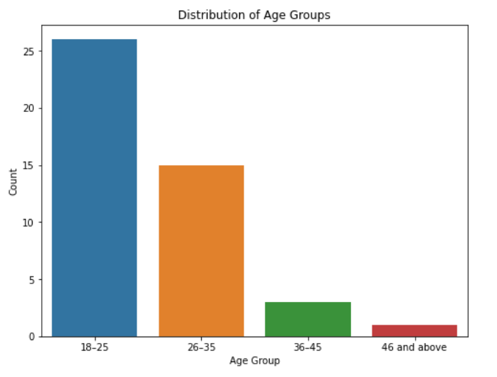

**Graph Interpretation:** The bar chart shows the distribution of respondents across different age groups. The majority of respondents fall within the 18–25 age group, followed by the 26–35 age group. This indicates that the workforce in the study is relatively young, which could influence the emotional states and stress management strategies observed.

**Conclusion:** Younger employees (18–25) dominate the dataset, suggesting that emotional intelligence training might be particularly beneficial for this demographic.

#### 

#### 2) Visualization of Emotional States at Work

**Fig.5.2**

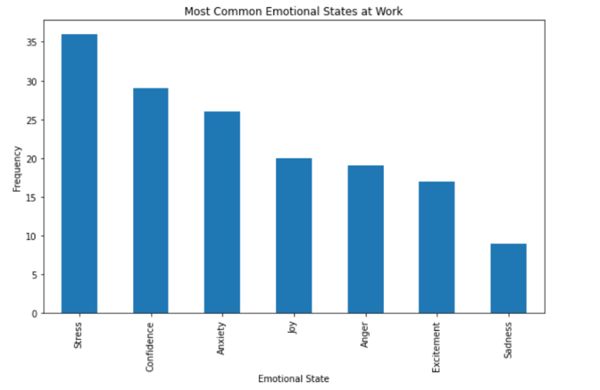

**Graph Interpretation:** The bar chart illustrates the most common emotional states experienced at work. Stress and confidence are the most frequently reported emotions, followed by anxiety and joy. This indicates that stress and anxiety are significant factors affecting workplace performance.

**Conclusion:** Stress and anxiety are prevalent in the workplace, highlighting the need for effective stress management and emotional support programs.

#### 3) Visualization of Stress Management vs. Productivity

**Fig 5.3**

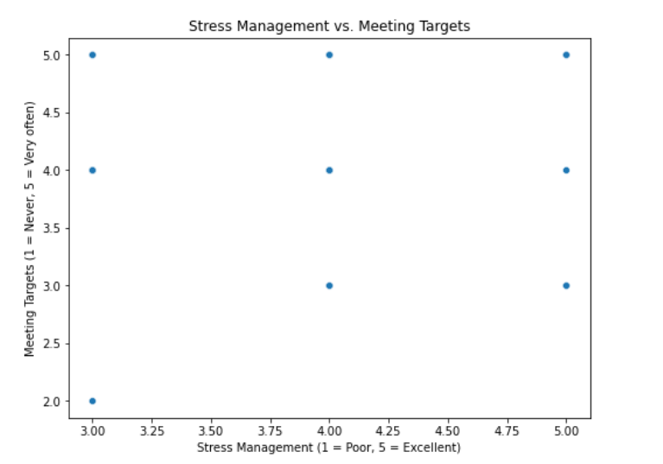

#### 

**Graph Interpretation**:The plot represents the relationship between stress management abilities and workplace productivity. The majority of respondents rated their stress management skills as 3 or above (on a scale of 1–5), indicating that most employees perceive themselves as moderately to highly capable of handling workplace stress. However, variations in productivity levels suggest that while effective stress management may contribute to better performance, other factors could also influence workplace productivity.

**Conclusion**:Since most employees report moderate to strong stress management abilities, organizations should continue promoting stress management training, mental wellness programs, and employee support initiatives. Strengthening these areas can help employees develop resilience and emotional regulation, leading to improved workplace performance and well-being.

#### 4) Visualization of Emotional Awareness vs. Productivity

**Fig 5.4**

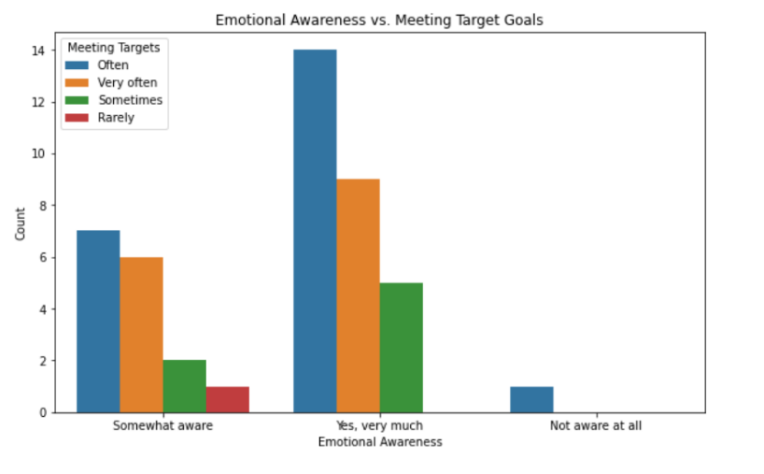

**Graph Interpretation**: The plot shows the relationship between emotional awareness and the frequency of meeting target goals. Respondents who are "very much aware" of their emotions tend to meet their targets more often compared to those who are only "somewhat aware" or "not aware at all." This suggests a positive correlation between emotional awareness and productivity.

**Conclusion:** Higher emotional awareness is associated with better performance in meeting targets, emphasizing the importance of emotional intelligence training in the workplace.

#### 5)Tolerance/Patience vs. Stress Management

**Fig 5.5**

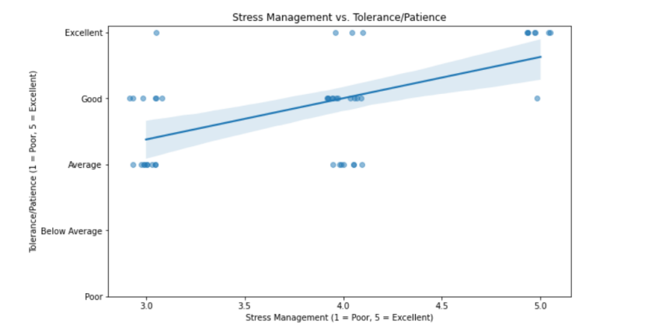

**Graph Interpretation:**The graph illustrates the relationship between tolerance/patience levels and stress management abilities among respondents. Employees with higher tolerance and patience generally demonstrate better stress management skills, while those with lower patience levels show greater variability in handling stress. This suggests that individuals who can remain patient in challenging situations are more likely to manage workplace stress effectively.

**Conclusion:**Higher tolerance and patience contribute to better stress management, which can lead to improved decision-making and emotional regulation in high-pressure work environments. Organizations should implement stress management workshops, mindfulness training, and resilience-building programs to help employees develop stronger coping strategies for workplace challenges.

#### 6) Team Collaboration Effectiveness

**Fig 5.6**

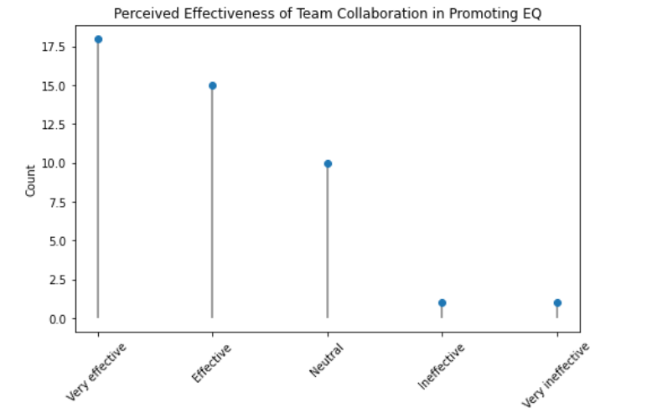

**Graph Interpretation:**The graph highlights respondents' perceptions of team collaboration in enhancing emotional intelligence. A majority of participants rated team collaboration as "Very Effective" or "Effective", indicating that working in a team environment positively contributes to emotional awareness, regulation, and overall workplace harmony. A small percentage of respondents rated it as "Neutral" or "Ineffective", suggesting that while team collaboration is generally beneficial, its impact may vary depending on workplace culture and individual experiences.

**Conclusion:**Effective team collaboration fosters emotional intelligence, enabling employees to develop better communication, problem-solving, and interpersonal skills. Organizations should encourage team-based projects, mentorship programs, and open communication strategies to enhance teamwork, emotional awareness, and overall workplace productivity.

#### 7) Educational Level Vs Emotional Impacts

**Fig 5.7**

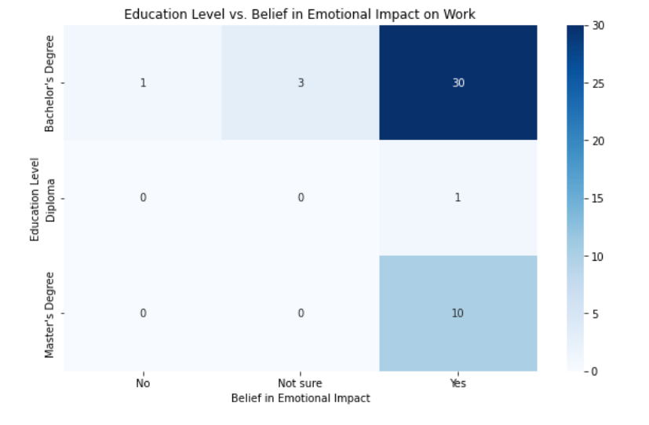

**Graph Interpretation:**The heatmap analysis illustrates the relationship between an employee’s educational qualification and their belief in the impact of emotions on work performance. The distribution reveals that individuals with higher educational qualifications (Master’s and Bachelor’s degrees) are more likely to acknowledge the role of emotions in their work. In contrast, respondents with lower educational qualifications (Diploma or equivalent) show more variation in their responses, with some being unsure or dismissing the impact of emotions on work performance.

**Conclusion**:Higher education levels may contribute to greater self-awareness and emotional intelligence, leading individuals to recognize the influence of emotions on productivity and decision-making. Organizations should integrate emotional intelligence training into professional development programs and encourage discussions on emotional well-being to enhance workplace awareness across all educational backgrounds.

#### 8) Emotional Stability and Productivity

**Fig 5.8**

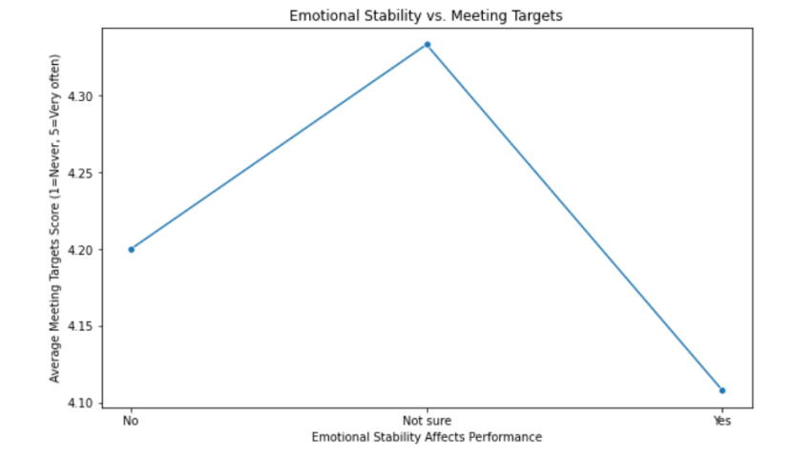

**Graph Interpretation:**The graph illustrates the relationship between emotional stability and workplace productivity. Employees who reported higher emotional stability tend to have more consistent productivity levels, while those with lower emotional stability showed greater fluctuations in meeting their targets. However, variations in the data suggest that emotional stability alone may not be the sole factor influencing productivity, as external factors such as workplace environment, stress levels, and job roles could also play a role.

**Conclusion:**While emotional stability contributes to consistent productivity, it is not the only determinant of workplace performance. Organizations should focus on emotional resilience training, stress management programs, and mental wellness initiatives to help employees develop better coping mechanisms and maintain productivity under pressure.

#### 9) Policy Effectiveness vs. Productivity

**Fig 5.9**

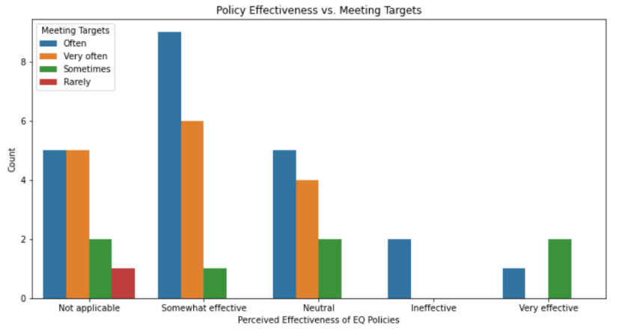

**Graph Interpretation:**The bar chart analysis examines how the perceived effectiveness of organizational policies on Emotional Intelligence (EI) influences workplace productivity. The distribution shows that employees who rate EI policies as somewhat effective or very effective tend to meet their work targets more frequently. Conversely, those who find these policies ineffective or not applicable exhibit lower productivity levels, indicating that a lack of structured EI initiatives may hinder workplace performance.

**Conclusion:**Well-designed Emotional Intelligence policies can positively impact employee productivity by fostering a supportive and emotionally aware work environment. Organizations should enhance EI initiatives, provide leadership training, and implement structured emotional well-being programs to improve employee engagement, stress management, and overall work performance.

#### 10)Visualization of Stress Management Vs Emotional Felt

**Fig 5.10**

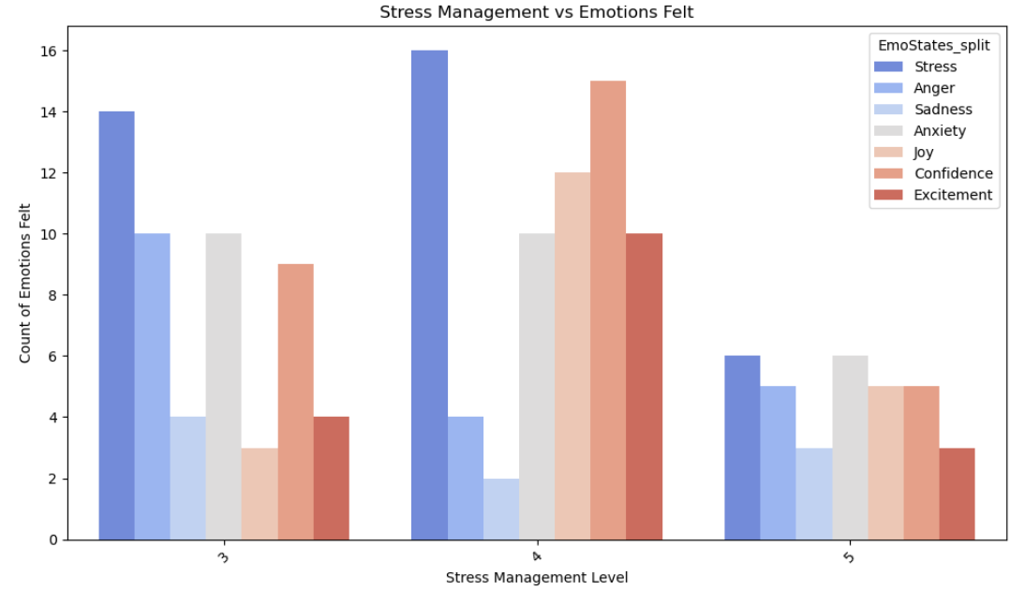

**Graph Interpretation:**The bar chart analyzes the relationship between stress management levels and the variety of emotions experienced by individuals. The distribution indicates that higher stress management levels tend to be associated with a more balanced mix of both negative (e.g., stress, anxiety, sadness) and positive emotions (e.g., joy, confidence, excitement). Individuals with lower stress management levels experience heightened stress and anger, while those with moderate to high stress management levels report more positive emotions like joy and confidence.

**Conclusion:**Effective stress management appears to promote a healthier emotional state, balancing both positive and negative emotions. Organizations should focus on enhancing stress management strategies, such as mental wellness programs, resilience training, and emotional intelligence workshops, to foster a more emotionally balanced and productive work environment.

### Hypothesis Testing & Statistical Part

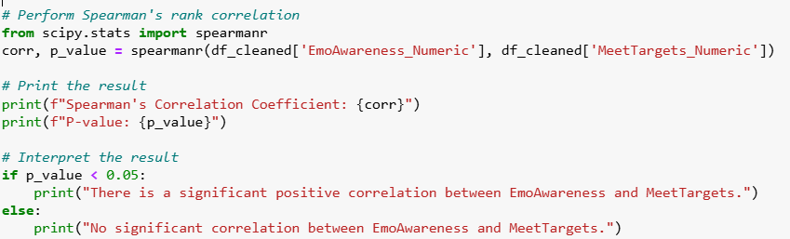

**Python Code snippet of Hypothesis Testing**

**Output**

Spearman's Correlation Coefficient: 0.9166666666666666

P-value: 0.02851395829882784

**Interpretation**

To validate the correlation between Emotional Awareness and Productivity, a Spearman’s rank correlation test was conducted.

* Spearman's Correlation Coefficient: 0.916 (strong positive correlation)
* P-value: 0.028 (statistically significant at p < 0.05)

#### 

Since the p-value is below 0.05, there is a significant positive correlation between emotional awareness and workplace productivity. This means that employees who are more aware of their emotions tend to perform better and meet their targets more frequently

### 5.4 Conclusion

This study explores the relationship between emotional intelligence, stress management, and workplace productivity. The findings highlight that emotional awareness and productivity significantly impact the performance and overall well-being of IT employees in Pune.

**Key Takeaways:**

* Emotional Awareness Enhances Productivity:IT Employees with higher emotional awareness tend to meet their work targets more frequently. This suggests that emotional intelligence training can help individuals regulate their emotions and improve workplace efficiency.
* Stress and Anxiety Are Major Workplace Challenges:Stress and anxiety are among the most frequently reported emotions at work. This highlights the need for stress management programs, mental health initiatives, and employee support systems to improve workplace well-being.
* Stress Management Correlates with Emotional Balance:Employees with better stress management skills experience a healthier mix of emotions, including increased joy and confidence while reducing stress and anger. Mindfulness training, resilience-building programs, and stress-reduction workshops can help employees cope better with workplace challenges.
* Team Collaboration Improves Emotional Intelligence:Employees who engage in effective teamwork tend to develop better emotional regulation, communication, and problem-solving skills. Organizations should encourage team-building exercises, mentorship programs, and open communication strategies to enhance teamwork and emotional intelligence.
* Educational Background Influences Emotional Awareness:Employees with higher education levels (Bachelor’s/Master’s degrees) are more likely to recognize the impact of emotions on their work. This suggests that emotional intelligence training should be incorporated into professional development programs to ensure employees across all educational backgrounds understand its importance.
* Emotional Stability Contributes to Consistent Performance:Employees who exhibit higher emotional stability tend to maintain steady productivity levels. This reinforces the need for mental wellness programs and emotional resilience training to help employees perform well under pressure.
* Strong Emotional Intelligence Policies Improve Workplace Performance:Employees who perceive EI policies as effective are more likely to meet their work targets, whereas those who view them as ineffective tend to struggle. Organizations should develop structured EI initiatives, leadership training, and workplace well-being programs to enhance overall productivity and engagement.

## Chapter 6 – Findings & Suggestions:

### 6.1 Findings

1. **Awareness of Emotional Intelligence and Its Impact on Work Performance** The survey responses indicate that while many employees are somewhat aware of the connection between emotions and workplace performance, a significant portion still lacks a comprehensive understanding. Emotional intelligence (EI) plays a crucial role in enhancing productivity, reducing stress, and fostering a collaborative work environment. Employees who are more emotionally aware tend to make informed decisions, handle work challenges better, and maintain a positive workplace culture. However, a gap exists in the level of understanding among employees, which suggests a need for targeted training and awareness programs.

Raising awareness of EI should be a priority for organizations aiming to improve workplace efficiency. Employees with a high level of EI are more adaptable, resilient, and capable of managing interpersonal relationships effectively. They exhibit better problem-solving skills and are more likely to remain motivated even during challenging situations. The survey findings indicate that employees who lack awareness about EI often struggle with communication, stress management, and maintaining professional relationships. Addressing this gap through dedicated programs, such as EI workshops and mentorship initiatives, can significantly enhance workplace harmony and performance.

1. **Emotional Stability and Workplace Performance** A significant portion of respondents admitted that their emotional stability directly impacts their work performance. Employees who reported better emotional stability were more likely to meet their target goals, handle stress efficiently, and maintain workplace productivity. Conversely, those who struggled with emotional regulation found it difficult to focus, leading to decreased efficiency and overall job dissatisfaction. Emotional stability influences decision-making, interpersonal relationships, and the ability to cope with workplace challenges. Organizations must recognize the importance of fostering emotional resilience among employees.

Employees who maintain emotional stability tend to demonstrate greater problem-solving abilities, collaboration, and leadership potential. When employees feel emotionally balanced, they are better equipped to manage their workload, engage with colleagues positively, and contribute meaningfully to organizational success. The survey results reveal that employees experiencing emotional distress often face difficulties in completing tasks efficiently, which can lead to increased workplace errors, misunderstandings, and a decline in morale. Providing stress management programs, employee assistance initiatives, and mental health resources can create a more emotionally stable and productive workforce.

1. **The Role of Emotional Intelligence in Employee Engagement** Employee engagement is a critical factor in productivity, and emotional intelligence significantly influences it. Employees who possess high EI are more engaged in their work, exhibit better teamwork, and display greater commitment to organizational goals. The survey highlights that employees with high EI tend to be more proactive, take initiative, and contribute positively to workplace culture. They are also more resilient in overcoming obstacles and handling workplace challenges efficiently.

In contrast, employees with low EI often experience workplace disengagement, leading to decreased performance, higher absenteeism, and lower job satisfaction. Organizations that invest in emotional intelligence training can enhance employee engagement by promoting emotional self-awareness, improving interpersonal relationships, and creating a positive work environment. A workplace that fosters emotional intelligence can witness a marked improvement in motivation, collaboration, and overall team synergy.

1. **Impact of Emotional Intelligence on Leadership Effectiveness** Leadership effectiveness is highly dependent on emotional intelligence. Leaders who exhibit high EI are better at handling conflicts, making decisions, and maintaining team morale. The survey responses indicate that employees value leaders who demonstrate empathy, active listening, and emotional regulation. Leaders with high EI create an inclusive and supportive work environment, which enhances employee satisfaction and loyalty.

Conversely, leaders who lack EI often struggle with team dynamics, leading to communication gaps, decreased trust, and higher turnover rates. Emotional intelligence training for leadership can improve managerial effectiveness by helping leaders develop skills in empathy, conflict resolution, and emotional regulation. A well-trained leadership team can inspire employees, drive performance, and cultivate a workplace culture rooted in emotional intelligence.

1. **Organizational Initiatives for Enhancing Emotional Intelligence** A notable finding from the survey is that most organizations do not have specific policies or initiatives aimed at enhancing emotional intelligence among employees. Despite the known benefits of EI, organizations have yet to integrate structured programs to improve emotional self-awareness and workplace relationships. This absence of structured EI training leaves employees to develop coping mechanisms independently, which may not always be effective. Companies that invest in emotional intelligence training can significantly improve team dynamics, leadership effectiveness, and overall workplace harmony.

Organizations that fail to implement EI initiatives risk lower employee engagement and higher turnover rates. Employees who lack emotional intelligence training may struggle to handle conflicts, provide constructive feedback, and work efficiently in team-based projects. By contrast, organizations that incorporate EI training into their employee development programs often experience enhanced workplace culture, reduced conflicts, and improved collaboration. Businesses should actively develop and integrate emotional intelligence policies to support employees' personal and professional growth, ultimately fostering a more productive and motivated workforce.

### 6.2 Suggestions

1. **Developing Emotional Intelligence Training Programs** Organizations should implement structured training programs to improve employees' emotional intelligence. These programs can include workshops, coaching sessions, and interactive learning modules focused on self-awareness, emotional regulation, and empathy. Companies can collaborate with experts in psychology and human resource development to design tailored training that addresses workplace challenges. By enhancing EI, employees can make better decisions, work collaboratively, and handle stress more effectively, leading to improved productivity and job satisfaction.
2. **Implementing Policies for Stress Management and Employee Well-being** Given that stress is a common workplace challenge, organizations should implement policies that help employees manage stress effectively. These policies can include flexible work arrangements, regular wellness programs, and access to counseling services. Encouraging employees to take regular breaks, promoting mindfulness practices, and introducing relaxation spaces in the workplace can significantly reduce stress levels. When employees feel supported, they are more likely to perform better and contribute positively to organizational goals.
3. **Promoting Team Collaboration and Emotional Intelligence in Leadership** Team collaboration plays a vital role in fostering emotional intelligence. Organizations should encourage team-building activities that focus on empathy, communication, and conflict resolution. Leaders should be trained to understand and manage their own emotions while also guiding their teams in developing EI skills. Emotional intelligence in leadership improves team morale, enhances decision-making, and creates a positive work culture. Companies that emphasize EI in leadership training will likely experience higher employee satisfaction and productivity levels.

### 6.3 Conclusion

Emotional intelligence plays a crucial role in enhancing workplace productivity, leadership effectiveness, and employee engagement. The survey findings emphasize the need for organizations to invest in EI training, stress management policies, and leadership development programs to foster an emotionally intelligent workforce. Employees with high EI are better equipped to handle workplace challenges, build strong relationships, and contribute meaningfully to organizational success.

Organizations that prioritize emotional intelligence can expect improved teamwork, reduced conflicts, and higher job satisfaction among employees. By implementing structured EI programs, fostering a supportive work environment, and developing emotionally intelligent leadership, companies can create a positive and thriving workplace culture. Ultimately, emotional intelligence is not just a skill but a necessity for organizations seeking to enhance employee well-being, drive performance, and achieve long-term success.

## 

## 

## 

## 

## 

## 

## Chapter 7 – Conclusion

### 7.1 Introduction

The present study provides a comprehensive analysis of the role of Emotional Intelligence (EI) in enhancing workplace productivity, particularly within the IT sector in Pune. Emotional intelligence, which encompasses self-awareness, self-regulation, motivation, empathy, and social skills, has emerged as a critical factor influencing employee performance, stress management, collaboration, and overall job satisfaction. This research highlights the growing importance of EI in modern work environments, where technical skills alone are insufficient to ensure sustained success.

The findings of this study indicate that employees with higher emotional awareness and regulatory abilities are better equipped to handle workplace stress, engage in effective communication, and maintain productivity even under challenging circumstances. The IT industry, known for its demanding nature, tight deadlines, and fast-paced work culture, requires professionals who can navigate complex interpersonal relationships, resolve conflicts, and adapt to ever-evolving project requirements. This study has established that emotional intelligence plays a significant role in ensuring that employees can meet these challenges effectively, thereby improving individual and organizational performance.

One of the key insights from the research is the positive correlation between emotional intelligence and stress management. Employees who possess higher levels of EI demonstrate better coping mechanisms, enabling them to handle work-related pressure efficiently. This, in turn, results in lower burnout rates, reduced absenteeism, and enhanced job engagement. The ability to manage emotions and maintain a balanced mental state contributes to overall workplace well-being, making EI training an essential component of organizational strategies aimed at improving employee resilience.

Furthermore, the study underscores the importance of emotional intelligence in fostering teamwork and collaboration. IT professionals frequently work in team-based settings where effective communication and interpersonal relationships are crucial. Employees with strong emotional intelligence can navigate diverse perspectives, provide constructive feedback, and resolve conflicts amicably. This contributes to a positive work environment, where teams can collaborate efficiently and drive innovation. Organizations that prioritize EI development among their workforce benefit from improved team cohesion, higher levels of engagement, and increased productivity.

Leadership effectiveness is another critical aspect influenced by emotional intelligence. The research findings suggest that leaders who exhibit high levels of EI are more successful in motivating their teams, handling workplace conflicts, and maintaining a supportive work culture. Emotionally intelligent leaders foster trust and transparency, which, in turn, boosts employee morale and loyalty. Organizations that invest in EI training for leadership positions create an environment where employees feel valued and empowered, leading to long-term organizational success.

The study also reveals that educational background plays a role in shaping employees' perceptions of emotional intelligence. Employees with higher educational qualifications tend to recognize the significance of EI in workplace performance and are more likely to implement emotional intelligence strategies in their professional lives. This suggests that organizations should integrate EI awareness programs into their professional development initiatives to ensure that employees across all educational levels understand and apply emotional intelligence principles effectively.

While the study provides valuable insights, it is essential to acknowledge certain limitations. The research was conducted within a specific geographical and industry context—Pune’s IT sector—which may not be entirely representative of other industries or regions. Additionally, the sample size was limited, and the reliance on self-reported data introduces the possibility of subjective biases. Future research can explore the impact of EI in other industries, conduct longitudinal studies to analyze long-term trends, and examine the effectiveness of EI training programs in enhancing workplace productivity.

### 7.2 Implications for Organizations

The findings of this research have significant implications for organizations aiming to optimize employee performance and workplace productivity. By incorporating EI training programs, businesses can enhance employees' ability to manage stress, build meaningful relationships, and make informed decisions. Organizations should consider implementing the following strategies:

1. Emotional Intelligence Training: Conduct regular workshops and training programs focused on self-awareness, emotional regulation, and empathy to equip employees with essential EI skills.
2. Leadership Development Programs: Encourage leaders to develop emotional intelligence skills to foster a positive work environment and improve team management.
3. Stress Management Initiatives: Introduce mindfulness programs, employee wellness initiatives, and work-life balance policies to help employees manage workplace stress effectively.
4. Workplace Culture Enhancement: Foster an organizational culture that prioritizes emotional well-being, encourages open dialogue, and values employees’ emotional intelligence as a key competency.

Future Research Directions

While this study provides meaningful insights into the relationship between emotional intelligence and productivity, future research can explore additional dimensions of EI in the workplace. Areas that warrant further investigation include:

* The impact of EI on remote work productivity and virtual team collaboration.
* Comparative analysis of EI’s role in different industries beyond IT.
* Longitudinal studies to assess the long-term benefits of EI training programs.
* Evaluating the effectiveness of AI-driven EI development tools in corporate settings.

In conclusion, emotional intelligence is an indispensable factor in workplace productivity, employee well-being, and organizational success. The IT sector in Pune, like many other industries, benefits significantly from employees who can regulate their emotions, communicate effectively, and work collaboratively. By investing in EI training and fostering a workplace culture that values emotional intelligence, organizations can enhance employee engagement, reduce stress levels, and drive higher levels of productivity. As workplaces continue to evolve, emotional intelligence will remain a key differentiator in ensuring sustainable professional success and organizational growth.

By recognizing the profound impact of EI and taking proactive steps to integrate emotional intelligence strategies into workplace practices, businesses can create a thriving, emotionally intelligent workforce that is well-equipped to navigate the complexities of the modern corporate world

## 8 References/Bibliography

**1.** **Books & Research Papers**

o Emotional intelligence and your success: steven j. Stein, ph.d. and howard e. Book, m.d. third edition / revised & updated

o The EQ Difference by Adele B. Lynn

**2.** **News Articles**

o What is Emotional Intelligence and why is it important? [The Hindu](https://www.thehindu.com/education/what-is-emotional-intelligence-and-why-is-it-important/article33537159.ece)

o The importance of emotional intelligence in work place. [Times Ascent](https://timesascent.com/articles/the-importance-of-emotional-intelligence-in-the-workplace/157411)

**3.** **Online Blogs**

o How emotional intelligence can boost productivity and performance [Inside HR](https://www.insidehr.com.au/how-hr-can-drive-productivity-through-emotional-intelligence/)

o Ensuring emotional intelligence in technical teams: What can team leaders Do? [Knol Skape](https://knolskape.com/blog/ensuring-emotional-intelligence-in-technical-teams-what-team-leaders-can-do/)

**4.** **Research Papers**

o Role of emotional intelligence on work attitude of employees an empirical study of selected IT companies in pune :[ShodGanga](https://shodhganga.inflibnet.ac.in/handle/10603/380973)

**5.** **Government sites**

o Ministry of labour and employment, Government of India -[Labour.gov.in](https://labour.gov.in/)

o Ministry of electronics and information technology [Meity.gov.in](https://www.meity.gov.in/)

**6.** **Citations**

o Emotional intelligence in the IT industry: A study on emotional intelligence among it professionals [Cardiometry](https://cardiometry.net/issues/no25-december-2022/emotional-intelligence-industry?)

o Emotional Intelligence in the workplace: Why is it important- [Conflict Resolution Training](https://conflict-resolution-training.com/blog/emotional-intelligence-in-the-workplace/)

## 9. ANNEXURE

### 9.1 Questionnaire:

1. What is your name

2. What is your Email ID

3. What is your Phone Number

4. What is your Age

5. Gender

6. Highest educational Qualification

7. Experience in IT

8. Designation:(Check all applicable)

9. Are you aware of the interrelation between emotions and their impact on work performance?

10. Do you believe that being aware of your emotions impacts your work?

11. Which emotions do you most commonly experience at work?

12. Does your emotional state positively influence your work productivity?

13. Are you able to remain calm and composed in the workplace despite environmental challenges?

14. Does your organization have policies or initiatives to enhance Emotional Intelligence or EmotionalSelf**-**Awareness?

15. If yes, how effective are these policies in improving Emotional Intelligence?

16. How effectively can you manage stress during work challenges?

17. How would you rate your tolerance and patience in handling workplace stressors?

18. How often do you meet your target goals at work?

19. Does your emotional stability affect your workplace performance?

20. In your opinion, how effective is team collaboration in promoting Emotional Intelligence?

### 9.2 Responses:

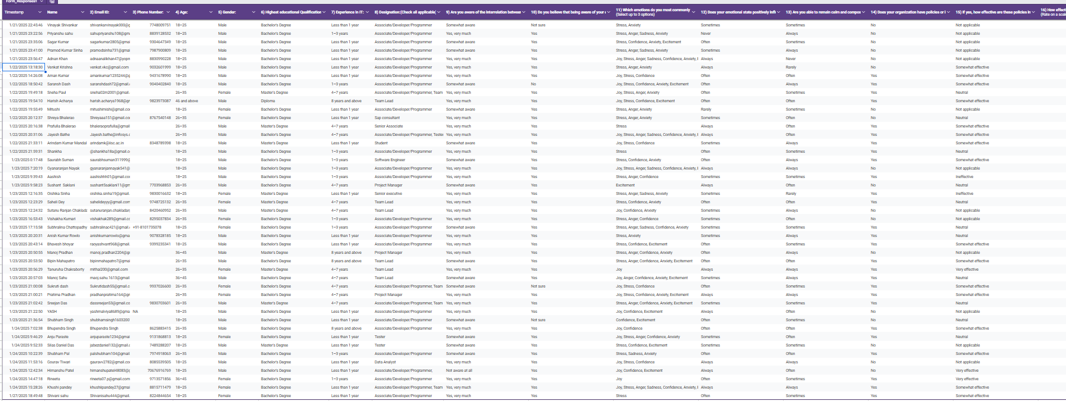

**Closing Note**

Thank you for taking the time to participate in this survey. Your insights are valuable to our research. If you have any additional comments or suggestions, feel free to share below